Name: Date:

Career:

Who am I? | I like this career because…  The Essential Skills I have that are needed for this career are…  The Work Habits I have that are needed for this career are…
What is my plan for achieving my goals? | The Essential Skills that I need to further develop for this career are…  The Work Habits that I need to further develop for this career are…
What are my opportunities? | What other experiences can I pursue that can help me apply and further develop my Essential Skills and work habits?

Save this reflection in your “All About Me” portfolio.

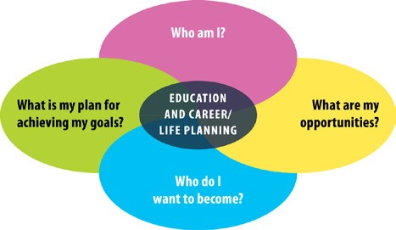
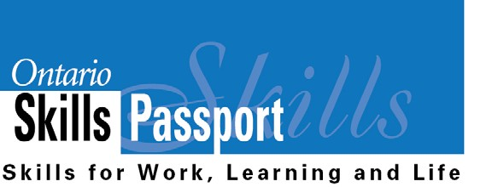
ontario.ca/skillspassport

